TONGUE OUTPUT
IMAGE SELECTION:
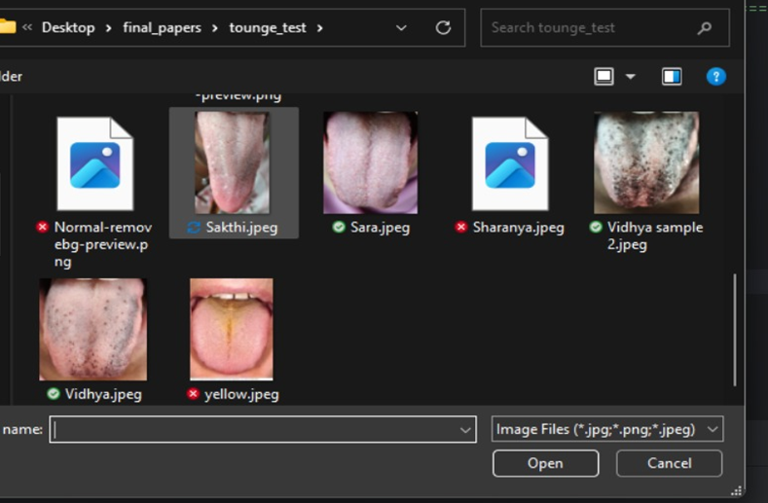
OUTPUT FOR SELECTED IMAGE :
